DESCRIPTION OF THE TEST | TEST DATA TO BE USED IF APPLICABLE | EXPECTED OUTCOME | ACTUAL OUTCOME | COMMENTS AND INTENDED ACTIONS.
Testing if the top bar displays correctly | N/A | Top bar displays correctly at the top of the screen | top bar behaves as expected | No further action
Testing the links on the top bar | N/A | Top bar links take user to expected place | Top bar links work mainly but link to account page doesn’t work correctly. | Change the url for the link that doesn’t work to rectify this issue.
Testing if the about us section displays correctly | N/A | About us section displays correctly and it’s readable. | Displays correctly.  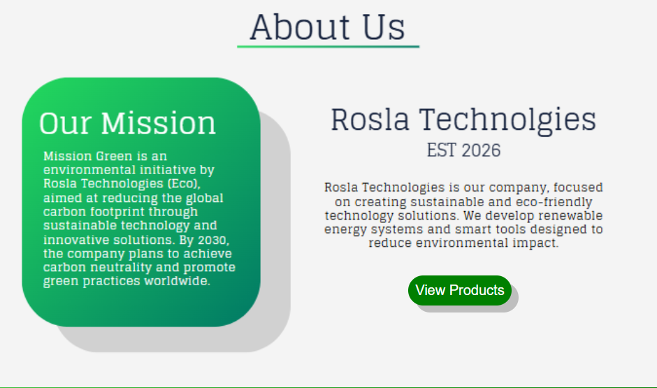 | No further action
Testing the home pages carbon footprint section. | N/A | Carbon footprint section displays correctly and its readable. | Displays correctly.  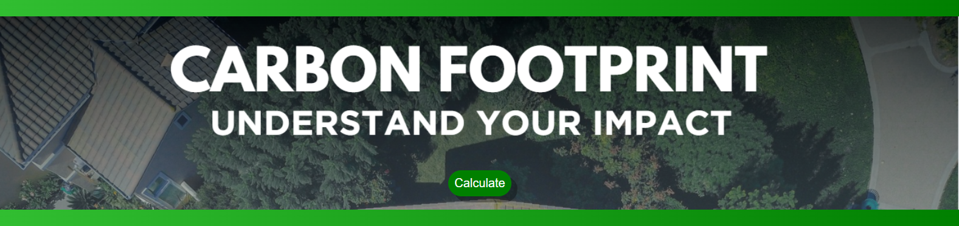 | No further action
Testing the home pages how do I reduce my footprint section? | N/A | How do I reduce my footprint displays correctly and is readable. | Displays correctly.  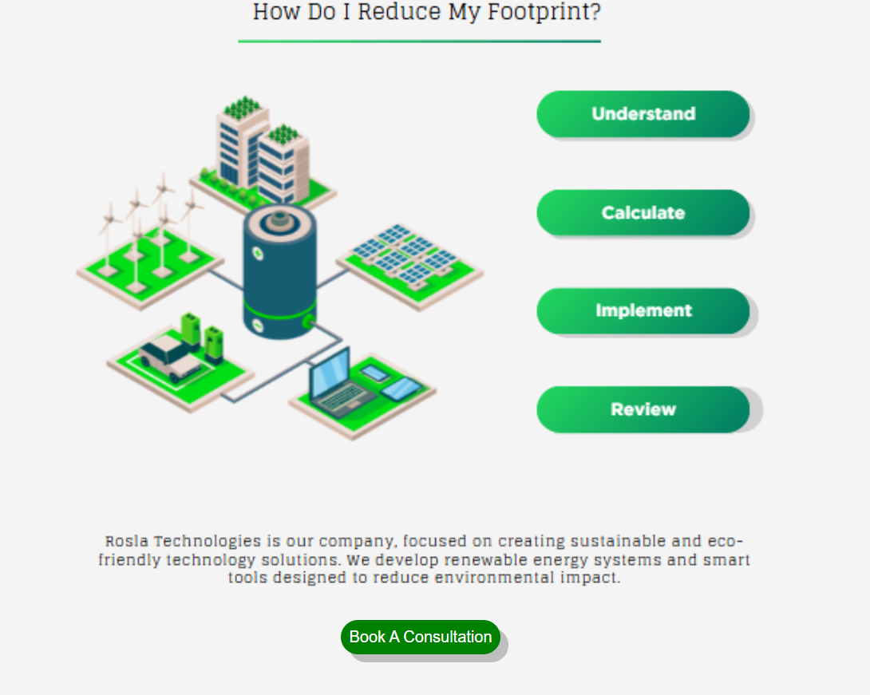 | No further action.

Change log
Developed a top bar
This top bar has links to all relevant places on the website. Such as the Home page, products page, booking a consultation page and the Users page.
HTML
<!DOCTYPE html>
<html lang="en">
<head>
<link rel="preconnect" href="https://fonts.googleapis.com">
<link rel="preconnect" href="https://fonts.gstatic.com" crossorigin>
<link href="https://fonts.googleapis.com/css2?family=League+Spartan:wght@100..900&display=swap" rel="stylesheet">
<meta charset="UTF-8">
<meta name="viewport" content="width=device-width, initial-scale=1.0">
<title>nav</title>
<link rel="stylesheet" href="../css/nav.css">
</head>
<body>
<div id="nav-bar">
<div id="bar">
<div id="nav-links">
<a href="../pages/index.html"><img src="../images/LOGO.png" alt=""></a>
<a href="../pages/index.html">Home</a>
<a href="">Products</a>
<a href="">Consultations</a>
</div>
<div id="user-box">
<a href="../pages/account.html"><img src="../images/user.png" alt=""></a>

</div>
</div>
</div>

</body>
</html>

CSS
*{
margin: 0;
}

body {
font-family: 'League Spartan', sans-serif;
}

a{
font-size: 20px;
color: black;
text-decoration: none;
}

#nav-bar{
width: 80%;
background-color: rgb(245, 245, 245);
display: flex;
align-items: center;
justify-content: center;
flex-direction: row;
padding: 10px 30px;
border-radius: 30px;

margin: 20px auto;
}

#nav-links{
display: flex;
flex-direction: row;
gap: 40px;
width: 50%;
align-items: center;
}

#nav-links img{
height: 30px;
padding-top: 5px;

}

#user-box{
display: flex;
width: 50%;
align-items: center;
justify-content: flex-end;
}
#user-box img{
height: 30px;
padding-top: 5px;

}

#bar{
width: 100%;
display: flex;
align-items: center;
justify-content: center;
flex-direction: row;
}

#body{
display: flex;
align-items: center;
justify-content: center;
}

Home Page
Below is the completed home page it provides information on the company and allows the users to be directed to different parts of the webs tie for good flow. such as going from the products
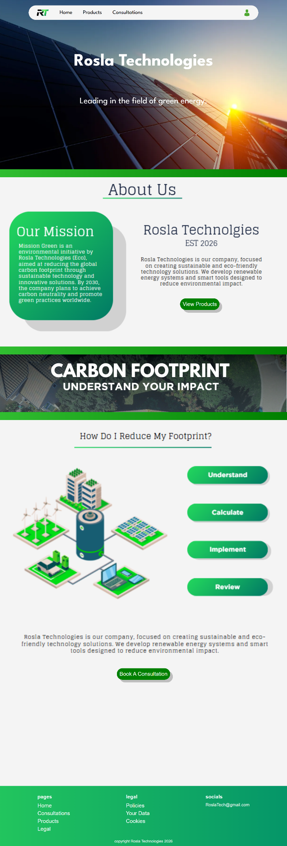
HTML
Provides a clear structure for the page along with ..

